HTML 5 Chapter 5- Students Handout
About Workshop
HTML5 is the fifth iteration of the Hypertext Markup Language, revolutionizing web development. With enhanced semantics and multimedia support, it offers a richer user experience. Features like Canvas enable dynamic graphics and animations, while offline capabilities cater to mobile and desktop apps. HTML5's responsive design and accessibility focus ensure a seamless, inclusive web. This standard has ushered in a new era of interactive and feature-rich web content.
Workshop1
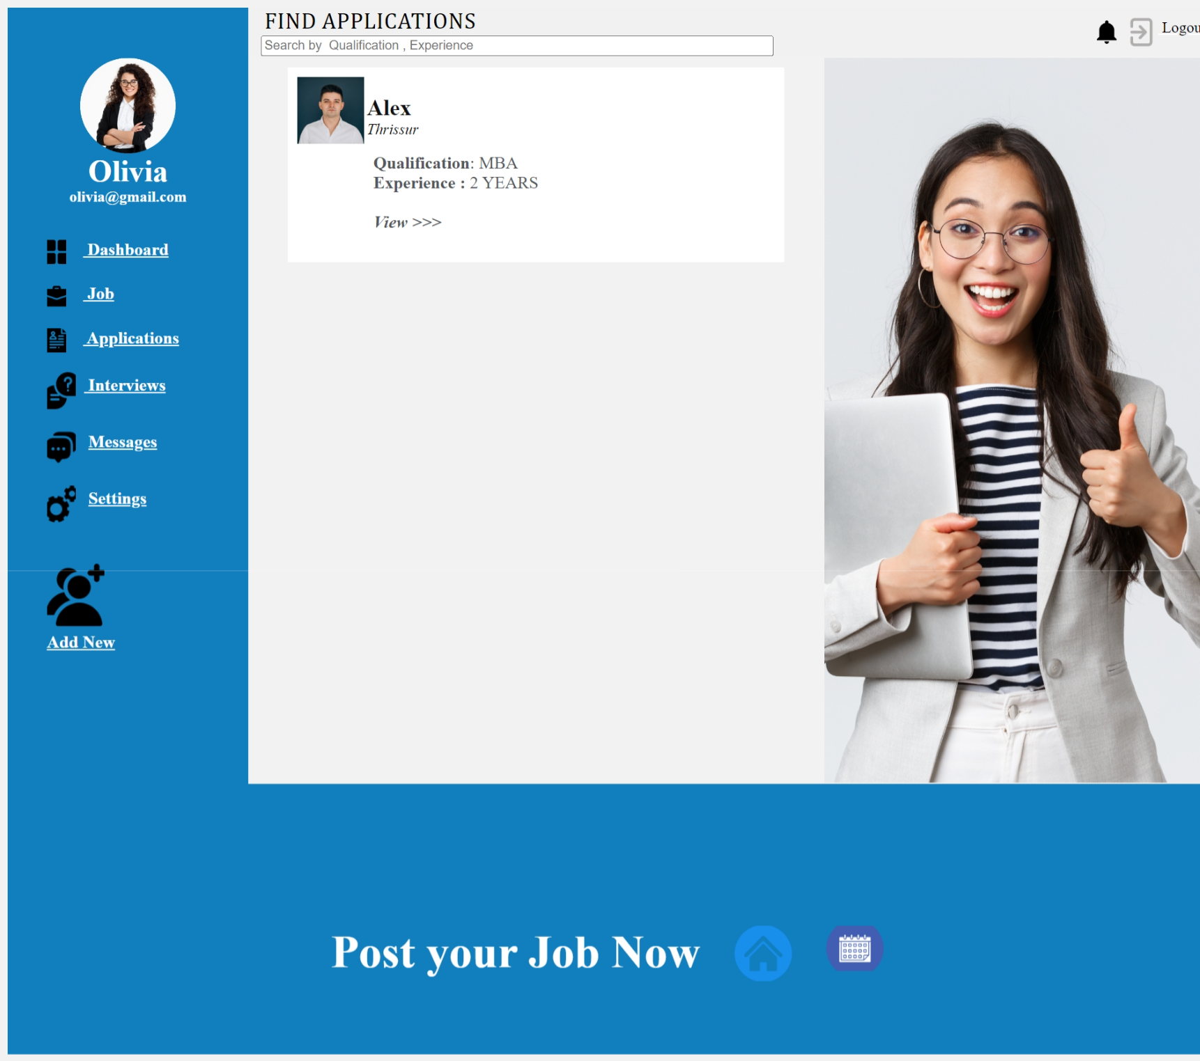

Expected Output
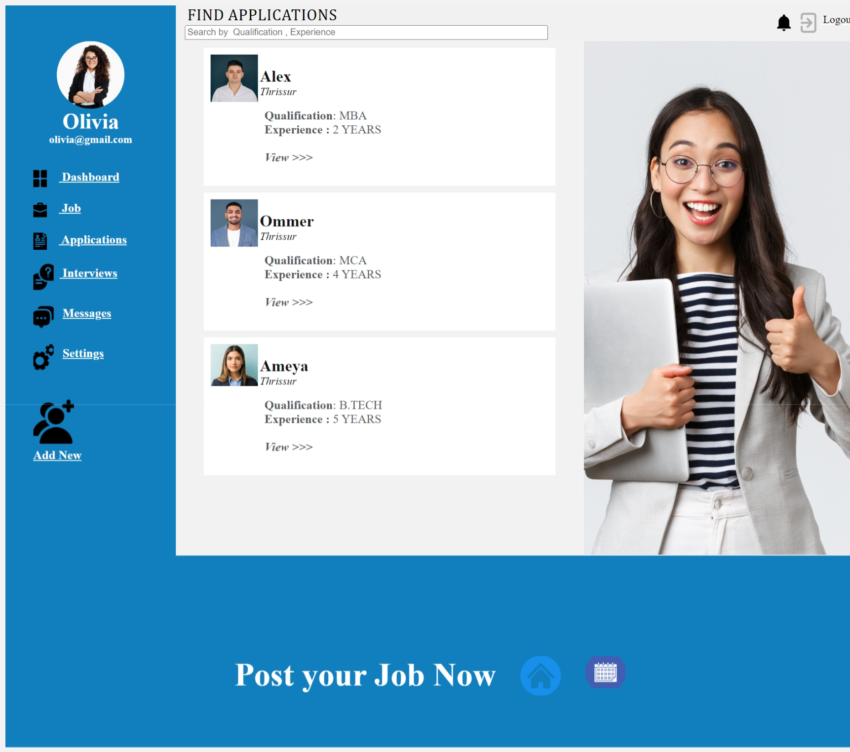
In HTML5, this code represents a webpage designed as a student workshop platform, with a title, author metadata, and favicon link in the `<head>` section. The `<body>` section sets background and link colours, and it uses a table structure to create different sections for the header, user profile information, potential content, and a footer with job-related actions and icons. The code includes image references with relative paths, and there are commented-out sections for possible future content or features.

Workshop2


Expected Output
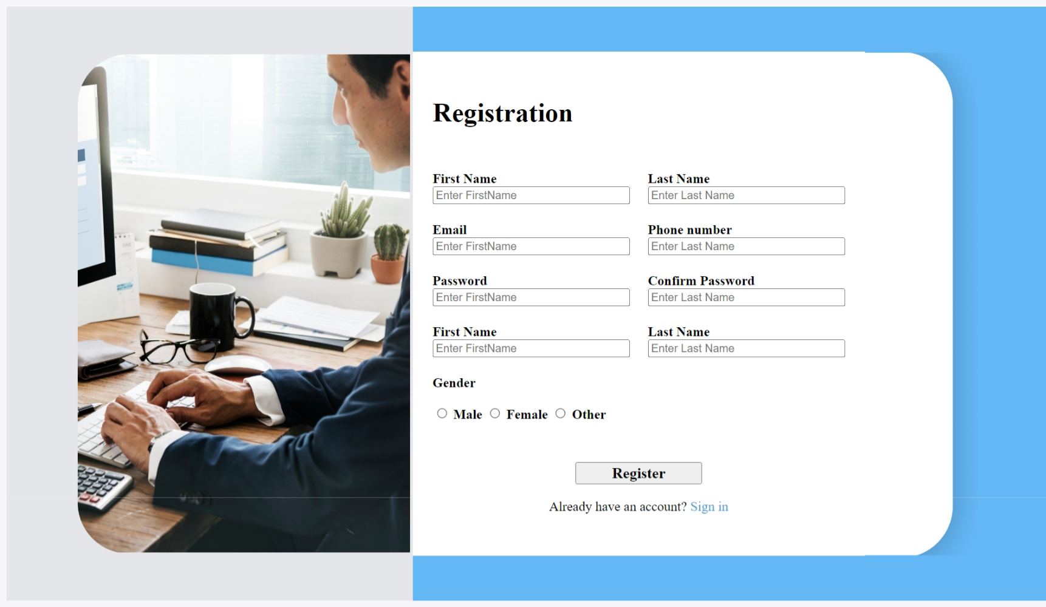
In HTML5, this code represents a student workshop webpage with the title "Workshop 2," author metadata, and a favicon link in the `<head>` section, defining the background and link colors in the `<body>`. The page utilizes a table structure to create distinct sections: a left column displaying an image, a center column for user registration with input fields for personal details, gender selection, and a "Register" button, and a right column displaying another image. This HTML5 webpage serves as a registration form for students interested in the workshop, facilitating the submission of their information for sign-up.
Workshop3
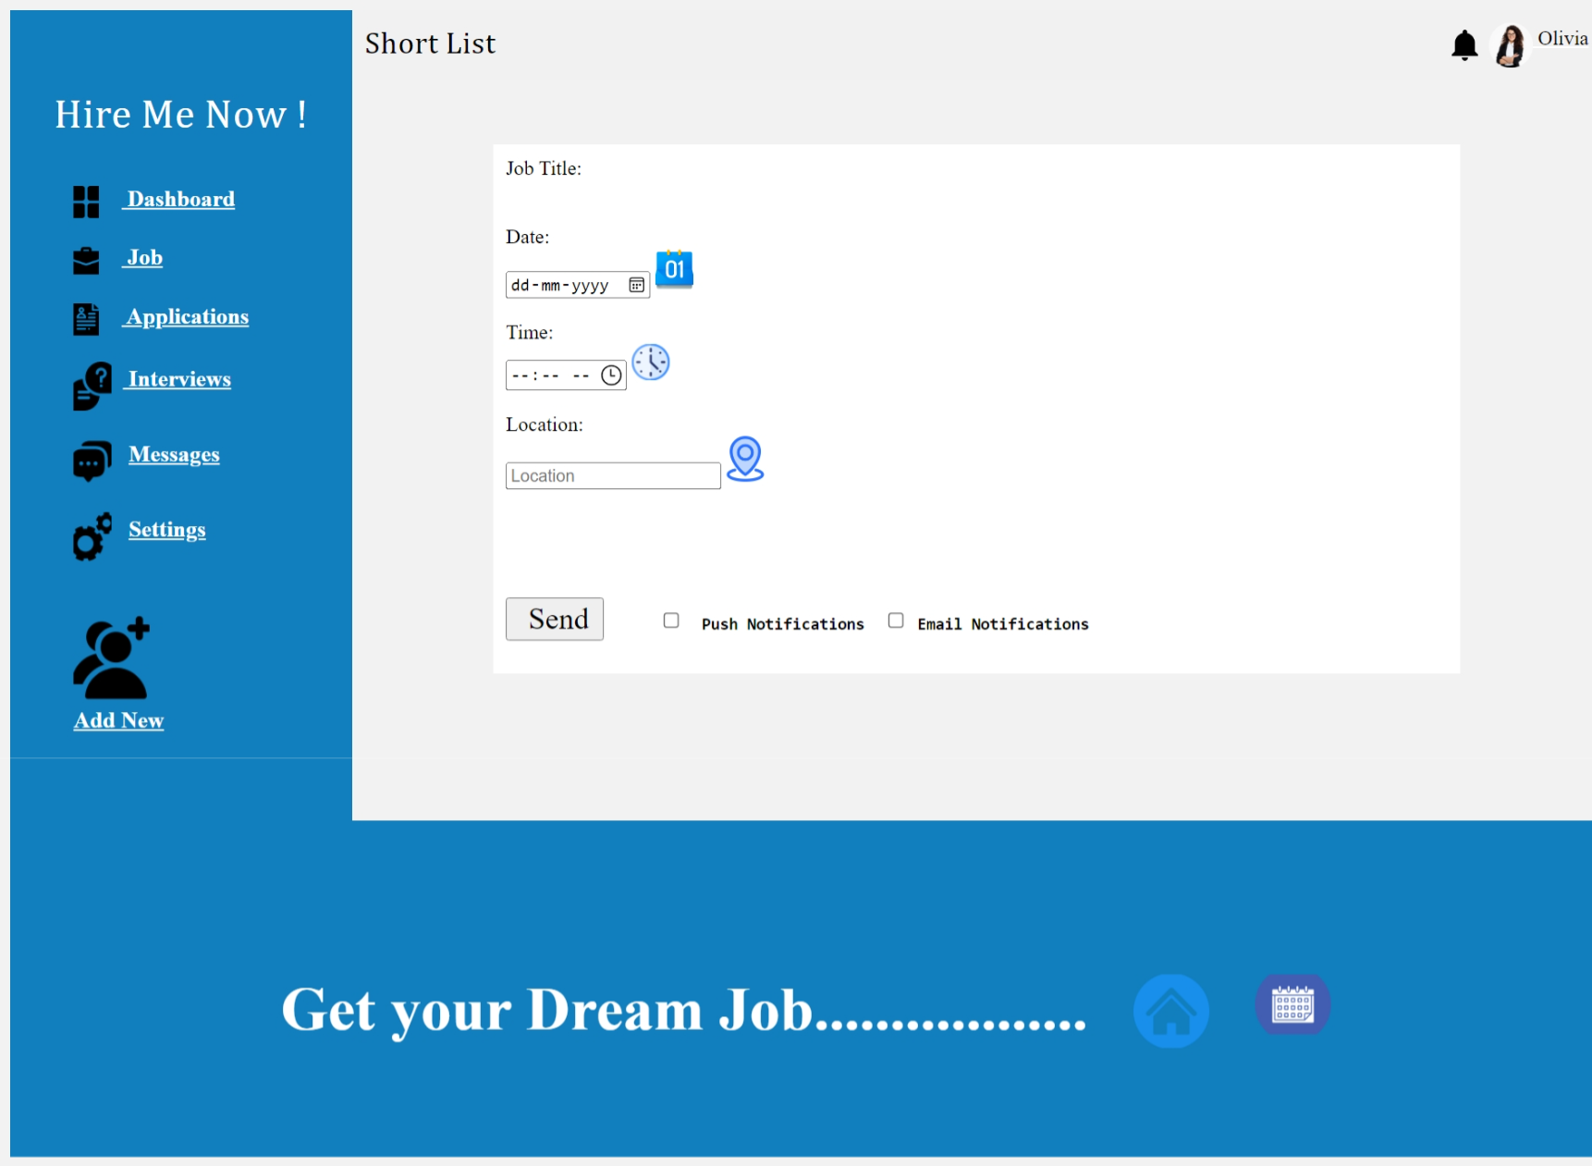
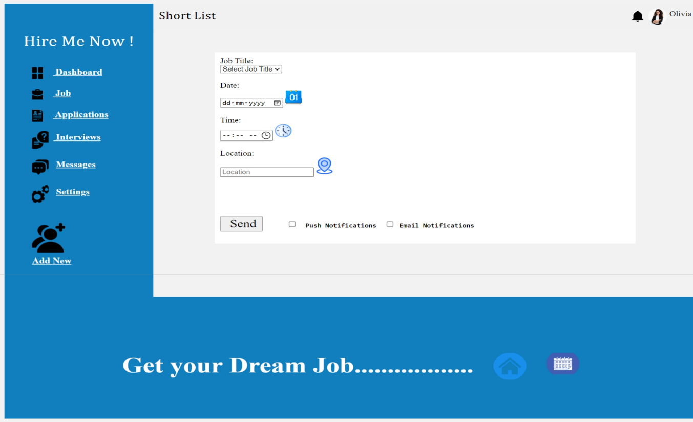
Expected Output
This HTML5 code represents a student workshop webpage titled "Workshop 3," which includes author metadata and a favicon link in the `<head>`. In the `<body>`, it defines background and link colors and employs a table structure to create distinct sections: a header row with "Short List" as the title and user information, a left column with user profile and navigation links, a central column allowing users to select job-related details and notification preferences, and a right column for potential content. The footer row promotes dream job opportunities and includes navigation icons. This webpage is tailored for a student workshop, focusing on job-related activities and user engagement through a structured interface.
Workshop4
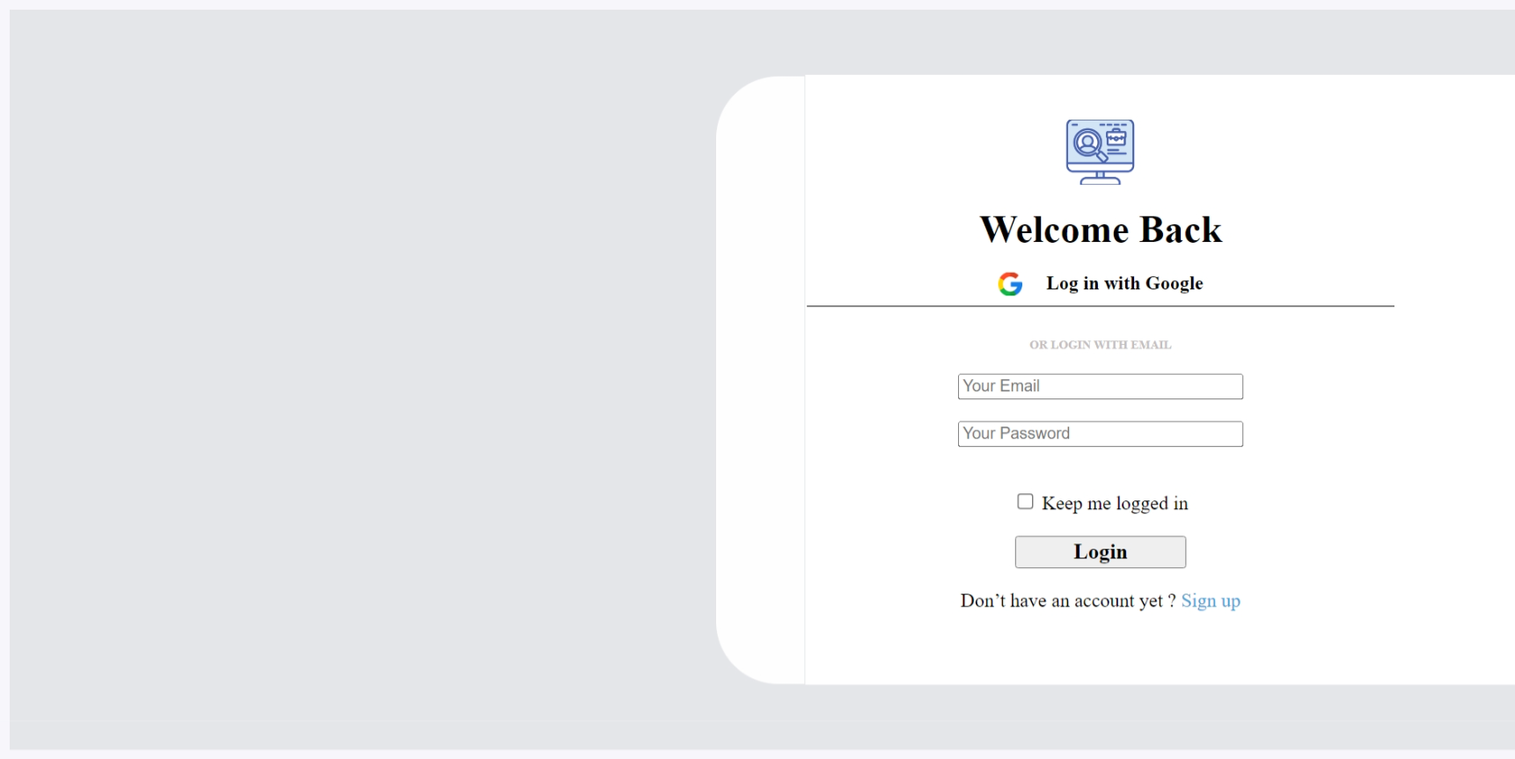
Expected Output
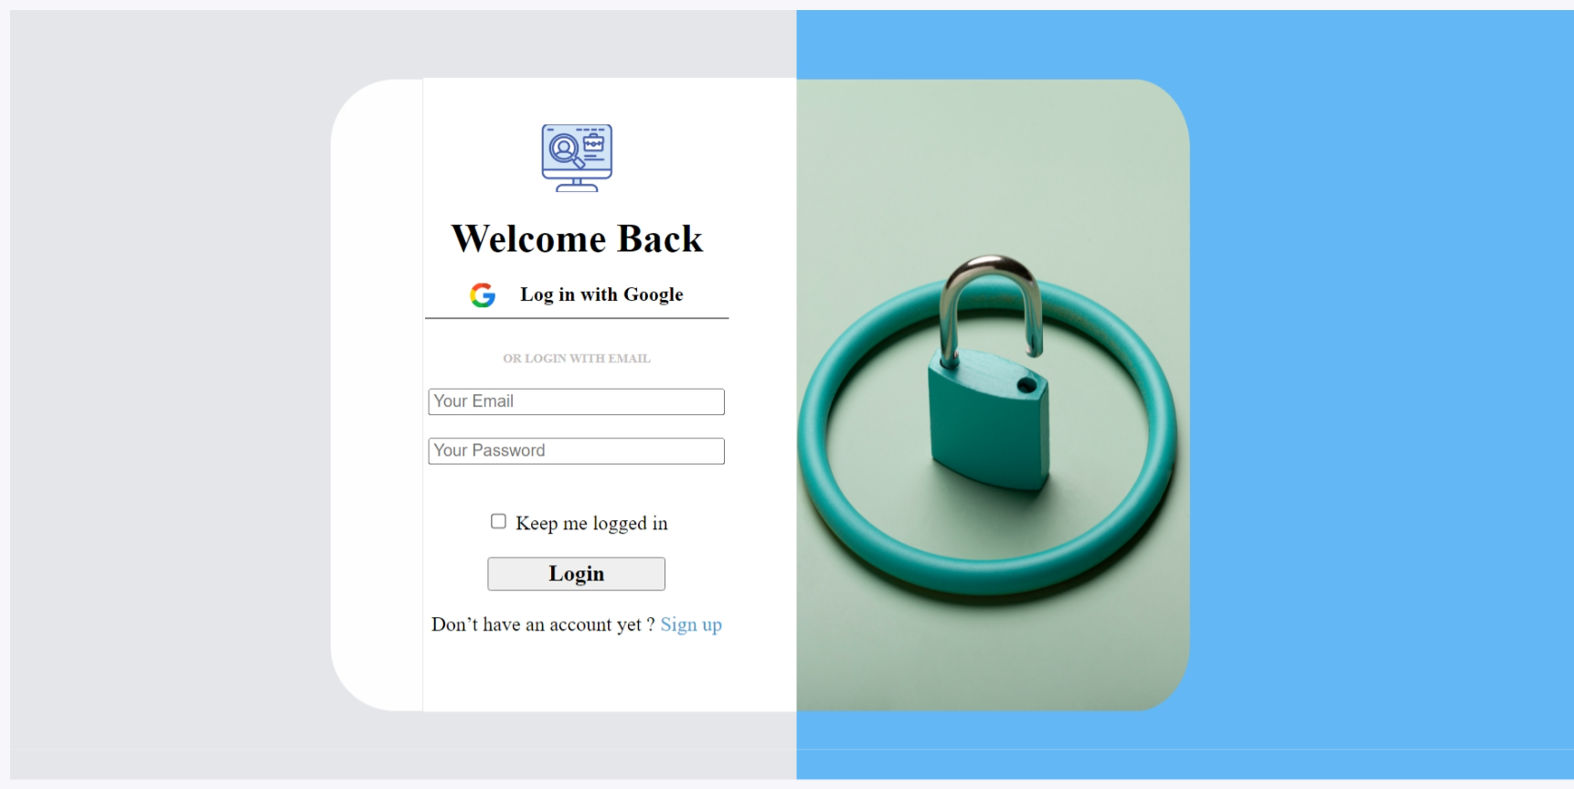
In HTML5, this code represents a student workshop webpage titled "Workshop 2" featuring a login portal with author metadata and a favicon link in the `<head>`. The `<body>` sets background and link colours, using a table structure to create two main sections:
1. The left column contains a login form offering options to log in with Google or an email account, allowing users to input their email and password, and providing a "Keep me logged in" option. A "Login" button is available, along with a link for users to sign up for a new account.
2. The right column displays an image for decorative purposes.
This webpage is designed to facilitate student logins and account creation for the workshop.
Workshop5
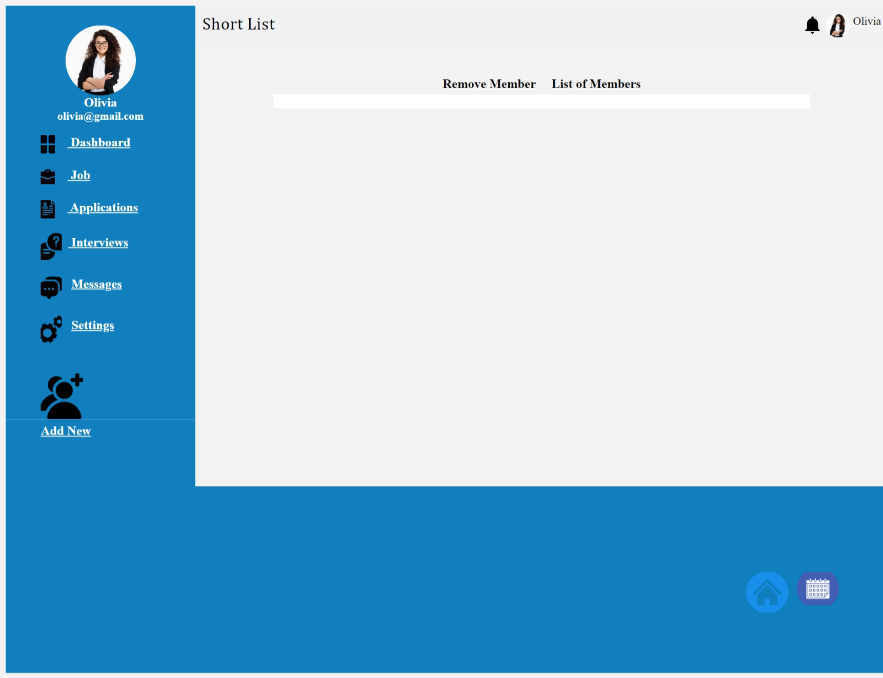

Expected Output
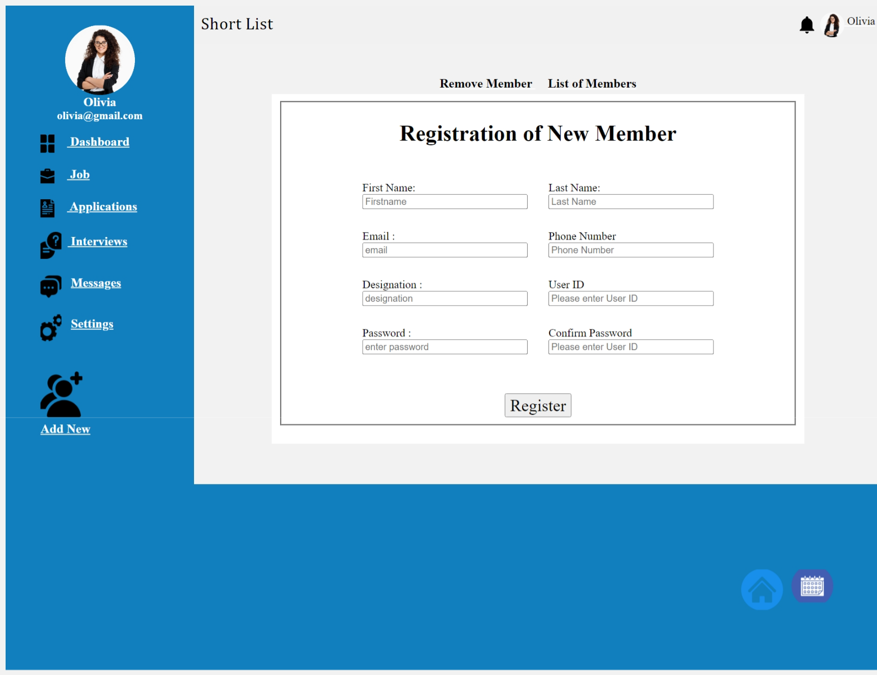
This HTML code represents a web page structure with a header containing profile information and navigation links, a registration form for new members in the main content section, and a footer with navigation icons, providing an overview of how HTML5 is used to create web pages.
Conclusion
HTML5 revolutionized web development with native support for multimedia, improved semantics, and enhanced form capabilities. It enabled rich graphics and animations through the `<canvas>` element and WebGL, transforming web gaming and visualization. Furthermore, HTML5's offline support with the Application Cache has made web apps more resilient in offline scenarios. Overall, HTML5 has ushered in a more dynamic, responsive, and engaging web experience.

